

Please return to: CVA HQ , PO Box 16974, Redditch, B97 9QL , England
Including: Joining fee £5, plus annual subscription of £12.00 (Overseas £15) payable to ‘CVA’

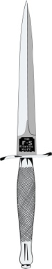
SERVING & VETERAN MEMBER APPLICATION FORM
(Please use ink and write in clear capitals – please read thoroughly prior to completing)

PERSONAL INFORMATION
SURNAME | Please remember to inform us of any future changes in your contact details.
FORENAMES
TITLE (Mr, Col, etc)
DATE OF BIRTH
ADDRESS
TOWN |  | PHONE
COUNTY |  | FAX
COUNTRY |  | MOBILE
POST CODE |  | EMAIL

SERVICE INFORMATION - (dates can be approximate – please enter N/A for any sections not applicable)

ENLISTMENT DATE |  |  | SERVICE NO
DATE CDO TRAINED |  |  | CAP BADGE
DATES AND DETAILS OF COMMANDO SERVICE

DETAILS OF ANY HONOURS/AWARDS
RETIREMENT DATE
PREFERRED AFFILIATED BRANCH
SIGNED: DATE:

If you are signing this form as a proxy for a disabled Commando wishing to join, please complete this section. | NAME
 | RELATION TO APPLICANT
 | PHONE NO

For Office use only – please DO NOT write below this line_______________________________ ______

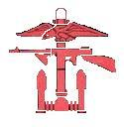
Received - Checked - Subs - Joining fee - Database - Label - Email - Card - Sent

